**DCIT 208 - SOFTWARE ENGINEERING**

**PROJECT TEAM INFORMATION SHEET**

**Team Name:** BuildTech Solutions  
**Project:** eBuildify - Construction Materials E-commerce Platform  
**Client:** Sol Little By Little Enterprise  
**Due Date:** Thursday, July 24, 2025 | 5:00pm

**1. Team Identity & Visual Introduction (1 pt)**

**Team Name & Logo**

**Team Name:** BuildTech Solutions  
**Team Motto:** "Building Tomorrow's Digital Infrastructure Today"



**Group Photo**

*[Group Photo Placeholder - Professional team photo or synchronous meeting screenshot showing all 7 members]*

**Team Introduction Video Playlist**

**YouTube Playlist URL:** https://www.youtube.com/@buildtechsolutions

**2. Member Biographies & Primary Contact (2 pts)**

**Team Member 1: Enoch Amarteifio_10716297 - Scrum Master/Frontend Developer**



**Bio:** Experienced full-stack developer with 3+ years in React/Node.js development and agile project management. Specializes in mobile-first PWA development and team coordination. Led 5+ successful e-commerce projects with expertise in user experience optimization and sprint facilitation. Passionate about delivering scalable solutions that drive business growth.

**Team Member 2: Ocran Bransford Charles_10716297 - Product Owner/UI/UX Designer**



**Bio:** Creative product strategist with strong background in user-centered design and business analysis. Expert in translating client requirements into actionable user stories and wireframes. Proficient in Figma, Adobe Creative Suite, and design thinking methodologies. Successfully delivered 10+ digital products with focus on conversion optimization and user satisfaction.

**Team Member 3: Abdul Rashid_11356950 - Backend Developer**

**

**Bio:** Senior backend engineer with expertise in PostgreSQL, Node.js, and API development. Specialized in building scalable microservices architecture and payment gateway integrations. Experience with cloud deployment, database optimization, and security best practices. Strong background in fintech and e-commerce backend systems with focus on performance and reliability.

**Team Member 4: Jimba Muzamil_22250012 - QA Engineer/Testing Lead**

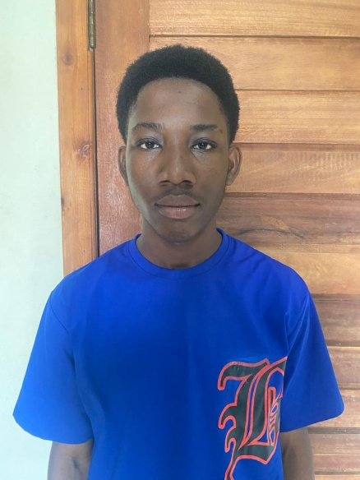

**Bio:** Detail-oriented QA professional with comprehensive experience in automated and manual testing. Expert in test case design, regression testing, and performance validation. Proficient in Selenium, Jest, and continuous integration testing. Committed to delivering bug-free software through rigorous testing methodologies and quality assurance processes.

**Team Member 5: [Name] - DevOps/CI-CD Lead**

*[Professional headshot placeholder]*

**Bio:** [To be provided - DevOps specialist with cloud infrastructure and deployment automation expertise]

**Team Member 6: Timeon Able_22117793 - Documentation & Demo Lead**

**

**Bio:** Experienced technical writer and presentation specialist skilled in clear documentation, client communications, and creating impactful visual content for technical and business audiences.

**Team Member 7: Dompreh Jerry Jabari_22039899 - Additional Developer**

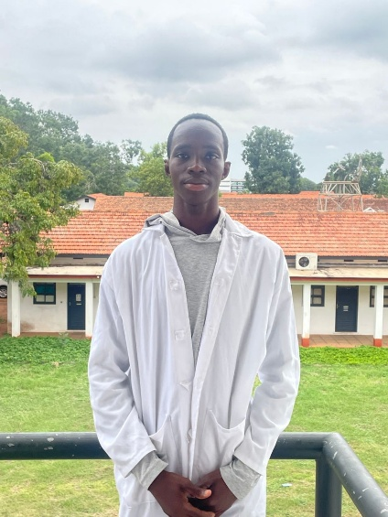

**Bio:** Versatile developer with strong technical skills in software development, debugging, and system integration, supporting seamless collaboration and project delivery within cross-functional teams.

**Primary Contact**

**Name:** Enoch Amarteifio  
**Role:** Scrum Master & Project Lead  
**Email:** amarteifioenoch4@gmail.com  
**Phone/WhatsApp:** 0542972982

**3. First Synchronous Meeting Evidence (1 pt)**

**Meeting Screenshot**

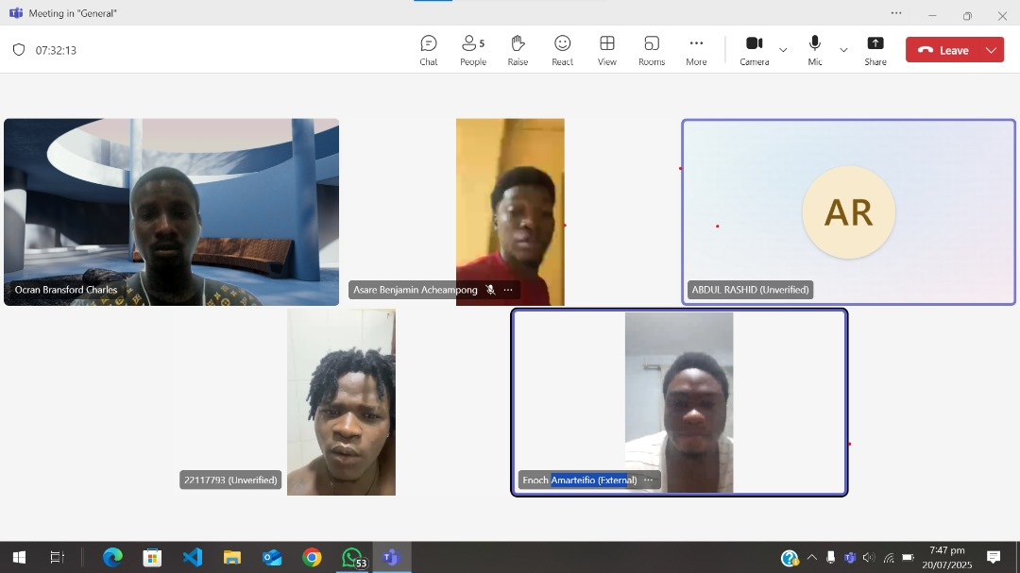

**Meeting Details**

* **Date/Time:** 20th June, 2025
* **Platform:** Teams
* **Duration:** 1hr

**Agenda Topics Covered:**

1. Project overview and client requirements review
2. Team role assignments and responsibilities
3. Technical architecture discussion
4. Timeline and milestone planning
5. Communication protocols and tools setup
6. Repository and project board initialization

**Action Items & Owners:**

* **Setup GitHub repository and organization** - Enoch Amarteifio (Due: 20th June, 2025)
* **Create initial project board with backlog** - Ocran Bransford Charles (Due: 27th June, 2025)
* **Database schema design review** - Abdul Rashid (27th June, 2025)
* **Test environment setup** - Muzamil (27th June, 2025)
* **CI/CD pipeline initial setup** - (27th June, 2025)
* **Project documentation structure** - (27th June, 2025)

**4. Team Agreement (4 pts)**

**a. Meeting Cadence & Etiquette**

* **Daily Standups:** Monday, Wednesday, Friday at 2:00 PM (15 minutes, camera-on required)
* **Sprint Planning:** Every 2 weeks, Tuesday 10:00 AM (2 hours, all members required)
* **Sprint Review/Retrospective:** End of each sprint, Thursday 3:00 PM (1.5 hours, all members required)
* **Chair Rotation:** Scrum Master chairs standups, Product Owner chairs sprint planning
* **Minutes Recording:** Rotating responsibility, documented in project board
* **Camera Policy:** Camera-on required for all formal meetings, optional for daily standups

**b. Project Management Tool**

**Primary Tool:** GitHub Projects (Scrum Board)  
**Board URL:** https://github.com/enoch-amart/BuildTech-Solutions   
**Backup Tool:** Trello (for client-facing updates)  
**Integration:** Slack for real-time communication and GitHub notifications

**c. Version Control Strategy & DevSecOps Rules**

**Branch Naming Convention:**

* main - Production-ready code
* develop - Development integration branch
* feature/[issue-number]-[short-description] - Feature branches
* hotfix/[issue-number]-[short-description] - Production fixes
* release/[version-number] - Release preparation

**Pull Request Requirements:**

* Minimum 2 reviewer approvals before merge
* All CI checks must pass (tests, linting, security scans)
* Branch must be up-to-date with target branch
* Squash and merge policy for feature branches

**CI/CD Checks:**

* Automated testing (Jest for unit, Cypress for E2E)
* ESLint and Prettier code formatting
* Security vulnerability scanning (Snyk)
* Code coverage minimum 80%
* Docker container security scanning

**d. Generative AI Usage Policy**

**Permitted Uses:**

* Code boilerplate generation and documentation templates
* Brainstorming and ideation sessions
* Code explanation and learning assistance
* Test case generation and debugging support

**Requirements:**

* All AI-generated code must be reviewed, understood, and explained by the team member
* AI usage must be documented in commit messages when applicable
* No direct copy-paste without comprehension and testing
* Original problem-solving and architecture decisions must be human-driven

**Tools Approved:** GitHub Copilot, ChatGPT, Claude (for documentation)

**e. Code of Conduct & Inclusivity Pledge**

**Our Commitment:**

* Maintain psychological safety where all team members feel comfortable expressing ideas
* Practice respectful communication and constructive feedback
* Embrace diverse perspectives and collaborative decision-making
* Support each other's learning and professional growth
* Address conflicts directly and professionally
* Maintain confidentiality of sensitive project information

**Inclusivity Standards:**

* Zero tolerance for discrimination based on any personal characteristics
* Ensure equal participation opportunities in meetings and decision-making
* Accommodate different working styles and time zones when possible
* Provide constructive feedback focused on work, not personal attributes

**f. Risk & Contingency Plan**

**Illness/Emergency Protocol:**

* Immediate notification to Scrum Master and team
* Workload redistribution among available team members
* Documentation of all work to enable seamless handovers
* Flexible deadline adjustments for genuine emergencies

**Non-Participation Management:**

* **First Warning:** Private discussion with Scrum Master after missing 2 consecutive commitments
* **Second Warning:** Team meeting to address concerns and create improvement plan
* **Final Action:** Escalation to course instructor with documentation

**Deadline Management:**

* Weekly risk assessment during sprint planning
* Early identification of potential delays with mitigation strategies
* Client communication protocol for scope or timeline adjustments
* Buffer time built into critical path activities

**Academic Dishonesty Prevention:**

* All code contributions tracked via GitHub commits with proper attribution
* Regular code reviews to ensure understanding and original contribution
* Documentation of external resources and AI tool usage
* Individual accountability through peer evaluations

**5. Repository & Agile Board Links (2 pts)**

**GitHub Repository**

**Organization:** BuildTech-Solutions  
**Repository URL:** [https://github.com/enoch-amart/BuildTech-Solutions]  
**Branch Protection:** Enabled on main and develop branches  
**Security Features:** Dependency vulnerability alerts, secret scanning enabled

**Agile Project Board**

**GitHub Projects Board:** [Project board link]  
**Board Type:** Scrum with Sprint planning view  
**Current Status:** Backlog populated with initial user stories and technical tasks

**Board Screenshot**

**Current Backlog Items Visible:**

* Epic 1: Order Management System (8 user stories)
* Epic 2: Payment & Checkout (6 user stories)
* Epic 3: Inventory Management (5 user stories)
* Technical Setup Tasks (Database, CI/CD, Testing framework)
* Documentation Tasks (API docs, User manual)

**Additional Project Context**

**Project Overview**

eBuildify is a comprehensive e-commerce platform for VillageTech, specializing in construction materials sales with advanced features including:

* Multi-tier user management (customers, contractors, admins)
* Ghana Card verification system
* Credit management with automated payment processing
* Distance-based delivery pricing
* Service consultation booking
* Real-time inventory synchronization

**Technical Stack**

**Frontend:** React 18, PWA, Tailwind CSS  
**Backend:** Node.js, Express, PostgreSQL  
**Payment Integration:** Flutterwave (MTN MoMo, Vodafone, Telecel)  
**Deployment:** Docker, AWS/Heroku  
**Testing:** Jest, Cypress, Postman

**Project Timeline**

**Duration:** 16 weeks (4 months)  
**Sprint Length:** 2 weeks  
**Target Launch:** December 15, 2025  
**Budget:** ₵174,944 total project cost

*This document serves as our team contract and will be referenced throughout the project lifecycle to ensure accountability and professional collaboration.*